Conditional Statements in C | HackerRank
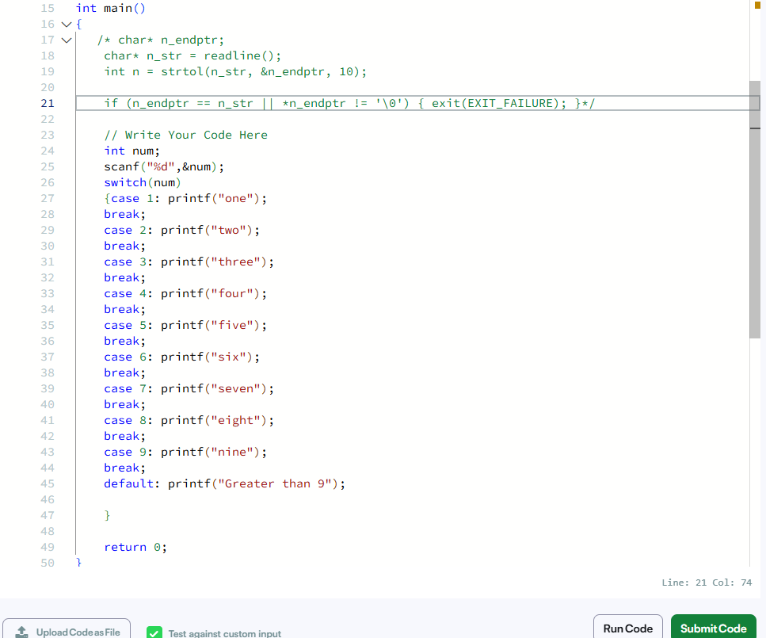

#include <stdio.h>
int main(){
int num;
scanf("%d",&num);
switch(num)
{case 1: printf("one");
break;
case 2: printf("two");
break;
case 3: printf("three");
break;
case 4: printf("four");
break;
case 5: printf("five");
break;
case 6: printf("six");
break;
case 7: printf("seven");
break;
case 8: printf("eight");
break;
case 9: printf("nine");
break;
default: printf("Greater than 9");

}

return 0;
}

